

SVKM’s NMIMS

Mukesh Patel School of Technology Management & Engineering

**Stock Market Analysis Dashboard**

Subject: Business Information Visualization and Analysis

**Academic Year: 2023-24**

|  |  |  |  |
| --- | --- | --- | --- |
|  | **Faculty mentor**: | **Submitted By:** | |
| MR SURAJ PATIL | | | Koyana Jadhav B253 | |
| (Assistant Professor) | | | Jash Bhurakhaya B259 | |
| Course: BTECH CE | | | Amol Wagh B268 | |
| MPSTME, NMIMS | | | Aditya Shinkar B269 | |

|  |  |  |
| --- | --- | --- |
| Sr NO | Table Contents | Page No |
|  | Introduction  * 1. SAS Studio Data Builder   2. Tableau Data Visualization | 3 |
|  | Data preparation Business Scenario-1  Business Scenario-2  Business Scenario-3  Business Scenario-4 | 4 |
|  | Dashboard Design Business Scenario-1  Business Scenario-2  Business Scenario-3  Business Scenario-4  Business Scenario-5 | 6 |
|  | Conclusion | 14 |
|  | References | 15 |

**Introduction**

In the ever-evolving landscape of finance, the imperative for investors to navigate markets with precision and insight has never been greater. The Stock Market Dashboard emerges as a pivotal solution, leveraging the prowess of Tableau to transform intricate financial data into actionable intelligence. With a focus on key players including Google, Apple, Twitter, NVIDIA, Tesla, and Facebook, this dashboard serves as a beacon for investors, offering a panoramic view of historical market dynamics. By harnessing the power of visualization, users gain access to a wealth of information, enabling them to discern trends, identify opportunities, and optimize their investment strategies with confidence.

At the heart of the Stock Market Dashboard lies a commitment to empowering investors with tools that transcend conventional analysis. Through Tableau's interactive interface, users embark on a journey through the annals of market history, uncovering insights that guide decision-making with clarity and precision. From scrutinizing past performance metrics to discerning sentiment trends across social media platforms, this project epitomizes the fusion of data science and financial acumen. As investors confront the complexities of modern markets, the Stock Market Dashboard stands as a testament to innovation, providing a transformative platform for navigating the intricacies of investment landscapes with finesse and foresight.

**Data Preparation**

1. **Import the dataset**

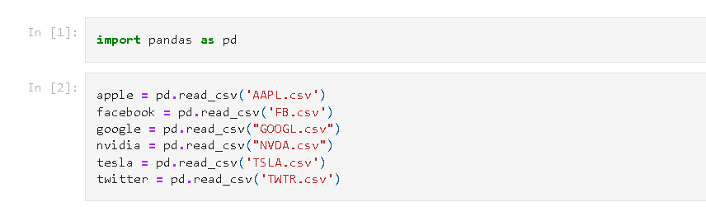

1. **Processing the datasets**

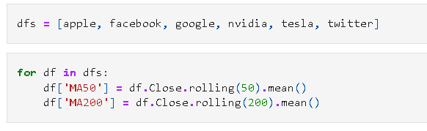

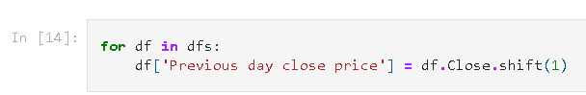

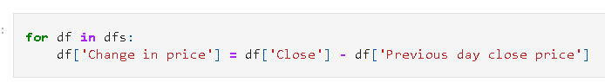

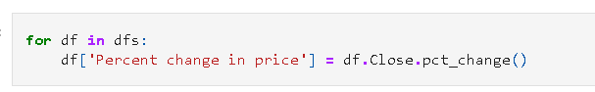

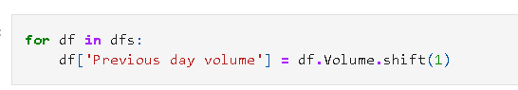

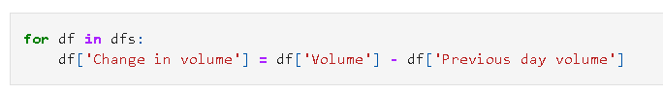

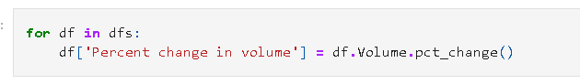

1. **Exporting the processed data**

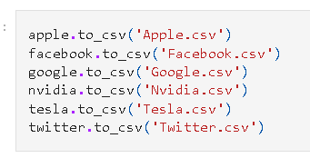

## Dashboard Design

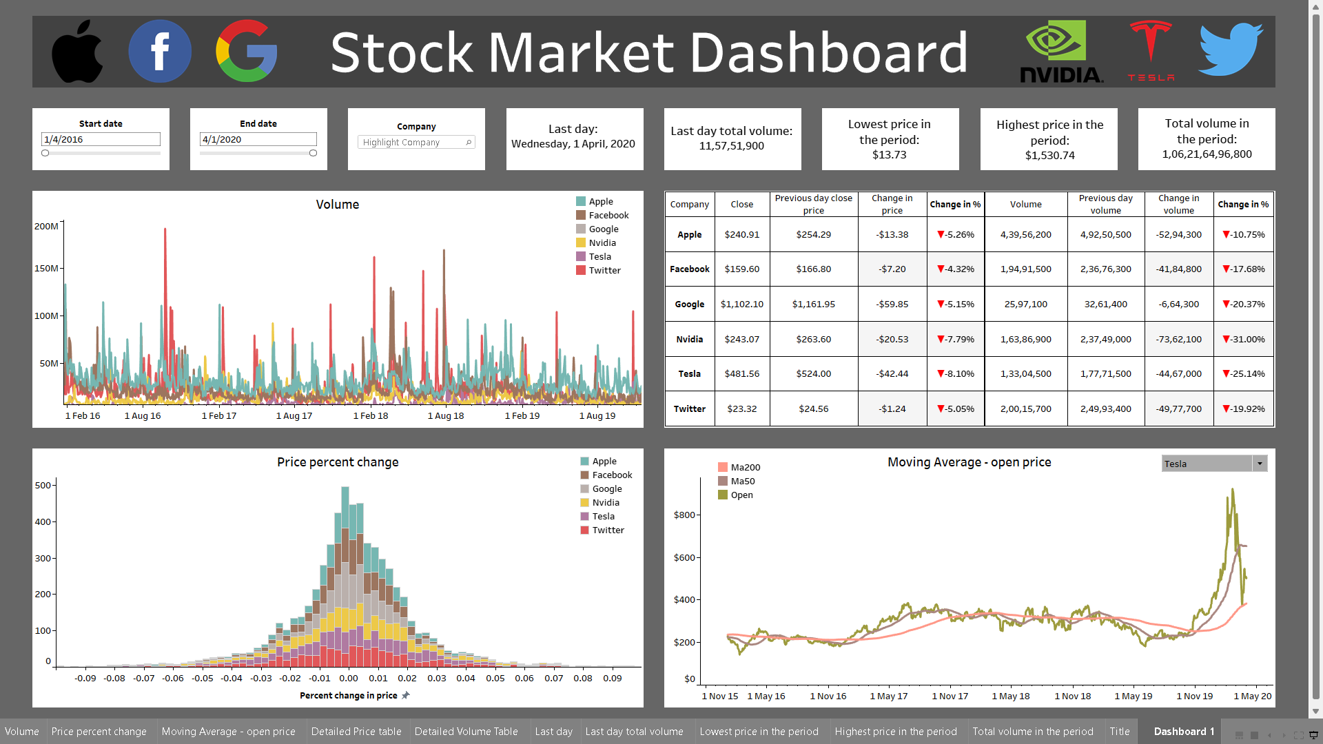

1. **Volume with dates**

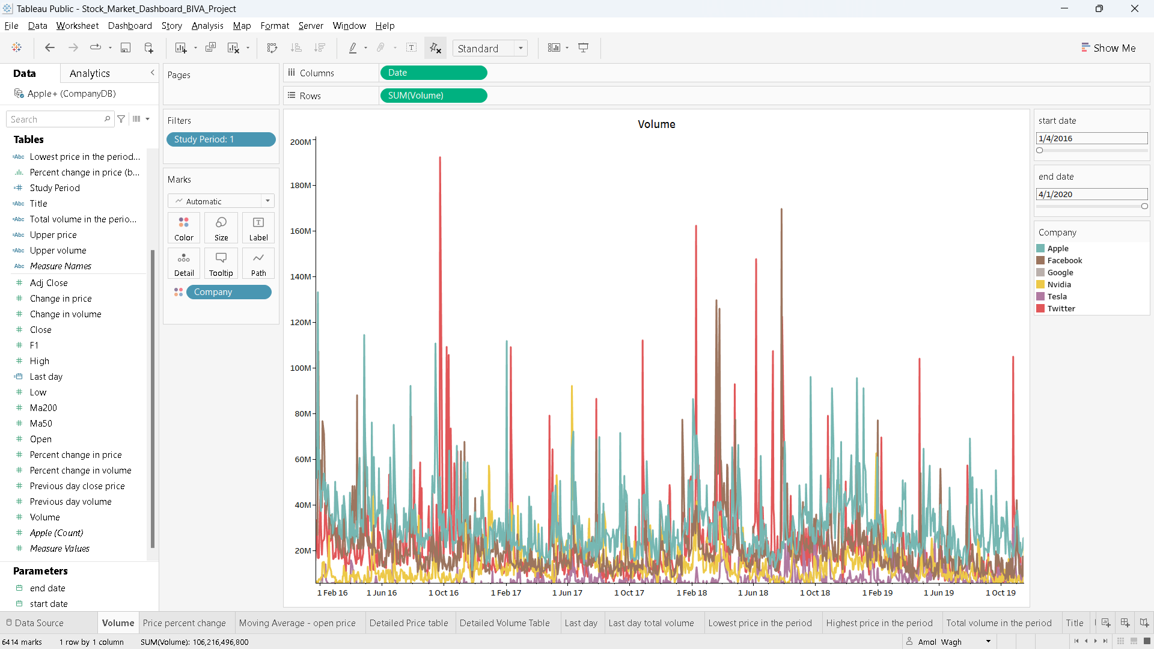

**Scenario:** You are analysing the volume of Apple stock over time. You want to see if there is a trend in the data.

**Action:**

* Use Filters on the Dashboard:
* Access the dashboard where the volume data of Apple stock is displayed.
* Utilize the filters provided on the dashboard interface. These filters may include options such as selecting a specific date range or comparing the volume of Apple stock to the volume of another stock.
* By selecting different date ranges, you can observe how the volume of Apple stock fluctuates over time. This helps in identifying any long-term trends or patterns.
* Compare with Other Stocks:
* Besides analyzing Apple stock in isolation, you can compare its volume to that of another stock.
* Use the filter options to select the other stock you want to compare with Apple. This could be a competitor in the same industry or any other stock of interest.
* By comparing volumes, you can gain insights into how Apple's trading activity relates to that of other stocks, which may provide additional context for your analysis.
* Download Data:
* If further analysis is required or if you prefer to work with the data in another program, you have the option to download the data from the dashboard.
* Look for a download button or option on the dashboard interface.
* Once downloaded, you can import the data into your preferred analysis tool or software for more in-depth examination. This could involve generating visualizations, conducting statistical analysis, or applying machine learning algorithms, depending on the complexity of your analysis goals.

1. **Price percent change**

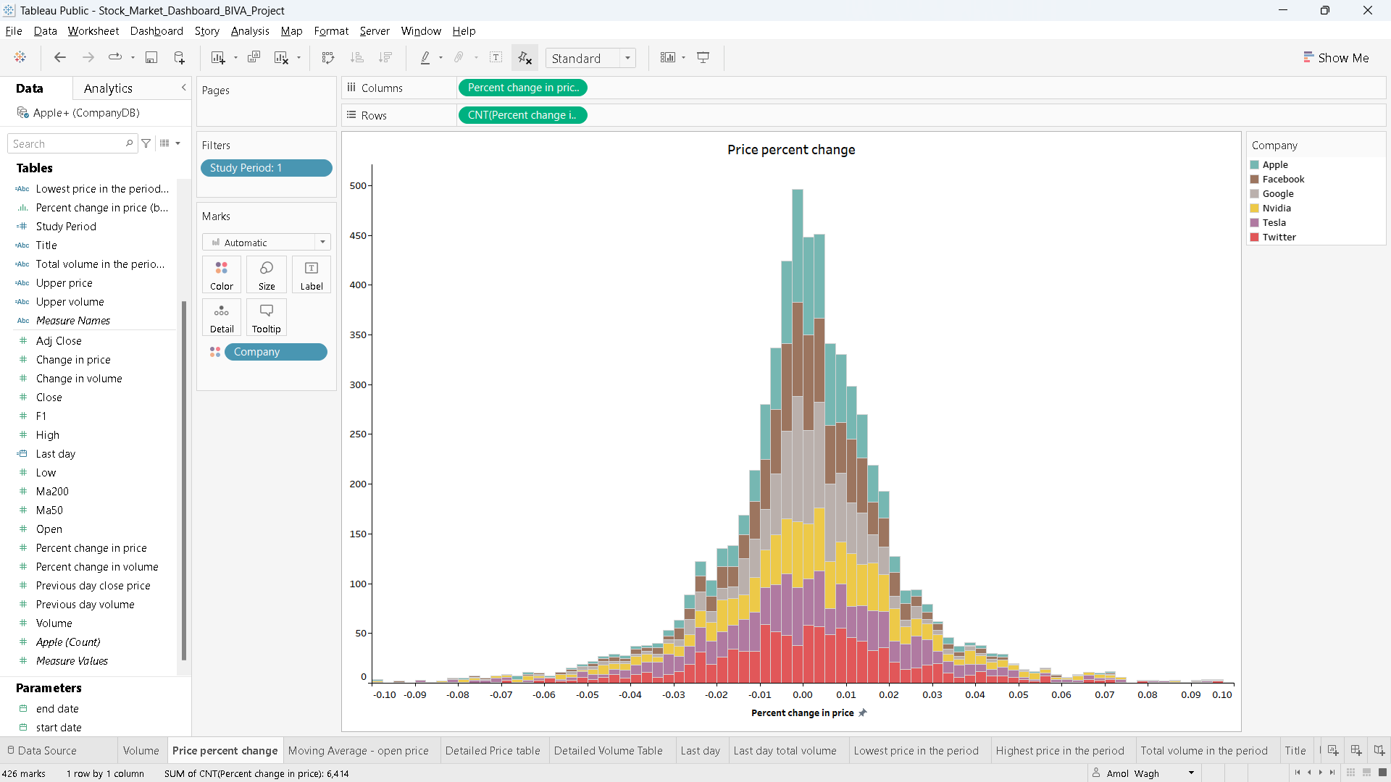

**Scenario:** You are interested in the distribution of stocks in a portfolio or mutual fund by company or sector. Additionally, you want to understand the allocation of assets in a portfolio, encompassing stocks, bonds, and cash.

**Action:**

* Utilize Dashboard Filters:
* Access the dashboard that displays the distribution of stocks in the portfolio or mutual fund.
* Utilize the filters available on the dashboard interface. These filters might include options to sort or group stocks by company, sector, price change, market capitalization, or asset class (stocks, bonds, cash).
* By adjusting the filters, you can dynamically view how the distribution changes based on different criteria. For example, you can analyse the distribution by sector to see the proportion of stocks from various industries within the portfolio.
* Visualize Distribution with Pie Charts:
* A pie chart is a suitable visualization tool for representing the distribution of stocks by company or sector.
* On the dashboard, locate the pie chart section that illustrates the distribution of stocks. Each segment of the pie chart represents a company or sector, and the size of each segment corresponds to its relative allocation within the portfolio.
* Analye the pie chart to gain insights into which companies or sectors dominate the portfolio's holdings and identify any over- or under-represented areas.
* Explore Asset Allocation:
* In addition to analysing the distribution of stocks, you are interested in understanding the overall asset allocation within the portfolio, which includes stocks, bonds, and cash.
* The dashboard may include other visualizations or sections dedicated to illustrating the allocation of assets across different classes.
* Utilize filters or interactive elements to drill down into the stock portion of the portfolio, allowing for a more detailed examination of individual holdings or sectors.

1. **Moving Average – open price**

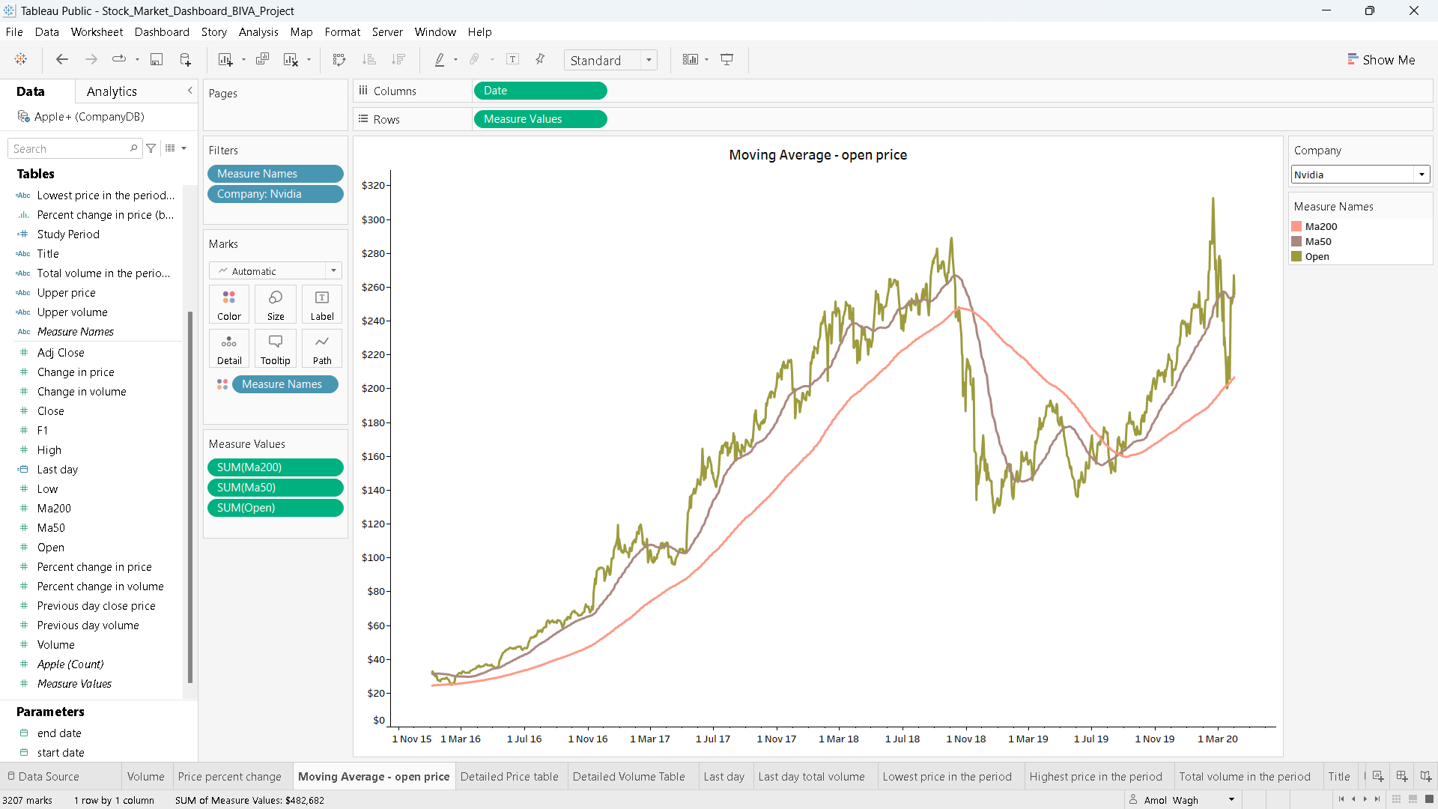

## Scenario and Actions for Moving Averages and Open Prices Graph:

**Scenario:** You are a stock market analyst or investor interested in understanding the price trend and potential support/resistance levels for a particular stock.

**From the graph you have:**

* **Moving Average (Blue Line):** This smooths out price fluctuations and helps visualize the underlying trend.
* **Open Prices (Orange Dots):** These represent the opening price for each time period, offering a more granular view of price action.

**Possible Actions:**

* **Identify Trend:**
  + **Upward Trend:** If the moving average is consistently **above** the open prices, this suggests a potential **upward trend**.
  + **Downward Trend:** Conversely, if the moving average is consistently **below** the open prices, this suggests a potential **downward trend**.
  + **Consolidation:** If the moving average and open prices are **close together**, it may indicate a period of **consolidation** where the price is neither strongly rising nor falling.
* **Support and Resistance:**
  + **Support:** Look for areas where the price dips towards the moving average but bounces back up. This area could be acting as **support**.
  + **Resistance:** Look for areas where the price tries to rise above the moving average but gets rejected. This area could be acting as **resistance**.
* **Confirmation with Other Indicators:** Moving averages and open prices are a starting point. Consider using them in conjunction with other technical indicators (e.g., RSI, MACD) for a more comprehensive analysis.
* **Further Research:** If you identify interesting trends or potential support/resistance levels, investigate further. Look for relevant news or events that might be influencing the stock price.

1. **Detailed price table**

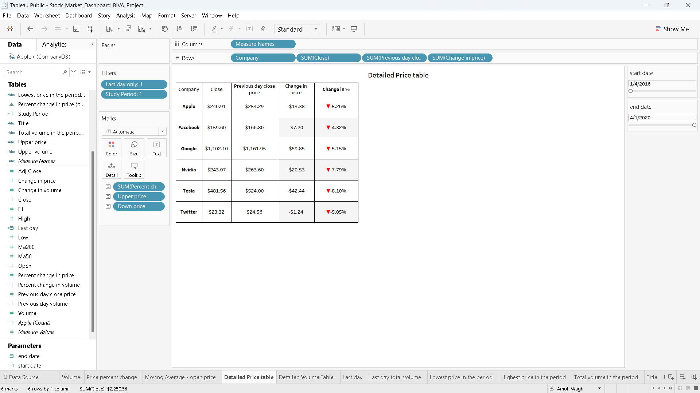

**Scenario:** You're a stock investor or analyst interested in comparing the current price of several stocks with their previous day's closing price to gauge their performance.

* **Information in the Table:**
* **Company:** Names of the companies listed (Apple, Facebook, Google, Nvidia, Tesla, Twitter)
* **Close Price:** The current price of each stock at the time the data was captured.
* **Previous Day Close:** The closing price of each stock on the previous trading day.
* **Change in Price:** The difference between the current price and the previous day's closing price.
* **Change in %:** The percentage change in price compared to the previous day's close. (Negative values indicate a decrease)
* **Actions You Can Take:**
* **Identify Gainers and Losers:** Quickly see which stocks have increased or decreased in price compared to the previous day's close.
* **Analyze Performance:** Use the change in price and percentage change to assess how each stock is performing relative to the previous day.
* **Compare Stocks:** Compare the performance of different stocks listed in the table.
* **Drill Down for Further Analysis:** If a particular stock's performance piques your interest, you can research it further to understand the reasons behind the price movement. This might involve looking at news articles, analyst ratings, or other financial data.

1. **Detailed volume table**



**Scenario:** You are a stock market analyst or investor following several USA stocks and interested in comparing their performance over the course of the day.

**Information in the Table:**

* **Company:** Names of the Indian companies listed (ABB India Ltd., ABM International Ltd., ACC Ltd., ADF Foods Ltd., etc.)
* **Current Price:** The current price of each stock at the time the data was captured.
* **52 Week High/Low:** The highest and lowest price at which each stock has traded during the past year.
* **Actions You Can Take:**
* **Identify Current Leaders:** See which stocks are currently trading at their highest price point within the last year (based on the 52 Week High column).
* **Identify Potential Buys:** Look for stocks trading closer to their 52 Week Low that might be undervalued based on this metric (**Disclaimer:** This is a simplified strategy and not a guaranteed method for selecting stocks).
* **Monitor Intraday Performance:** Since the table doesn't show previous day's closing prices, you can't directly assess how much each stock has moved throughout the day. However, you can monitor the current price and potentially compare it to other price quotes or charts to gauge its intraday performance.
* **Further Research:** If a particular company's current price or its position within its 52-week range interests you, you can research it further to understand its fundamentals, news or analyst ratings.

**Conclusion**

The Market Insights Dashboard offers a comprehensive solution for investors, traders, and financial professionals to efficiently track and analyze stock market data. With real-time updates, historical analysis tools, customizable features, and revenue streams from subscriptions, advertising, data licensing, and consulting services, the dashboard provides value and convenience to users while positioning itself for sustained growth in the financial technology sector.

**References**

https://www.kaggle.com/datasets/jacksoncrow/stock-market-dataset